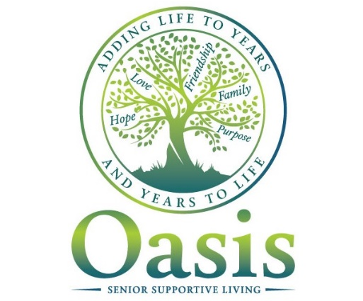

Information Session

Oasis is a seniors-driven program that helps support seniors living in the community.
Queen’s University is looking to expand Oasis to your building.

Community
Activity
Nutrition

If you are interested in learning more about Oasis and how you can be involved, please join us on Tuesday, November 20 at 1 pm in the Common Room on the main floor to hear more and share your ideas.
A project led by Queen’s University
And supported by the government of Ontario
The views expressed in the publication are the views of the Recipient and do not necessarily reflect those of the Province.
Ministry of Health and Long Term Care

